Merge sort

* Break into halves
* Sort the halves
* Then merge them back together

Function definition – Generative Recursion

**Signature, purpose and stub**

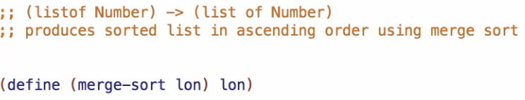

**Examples**

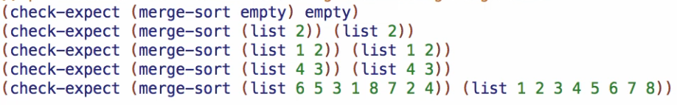

**Template**



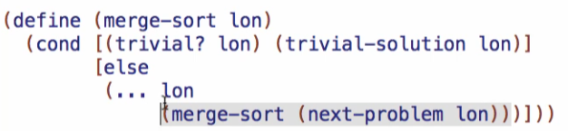

**Code body**

Trivial cases – 2

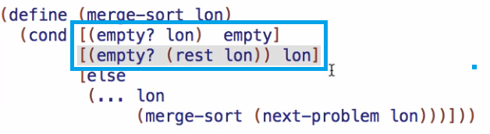

Recursive call

* Should be 2 recursive calls since we are splitting the list into two
* Then we **merge** those two back together
  + Merge is a wish list entry

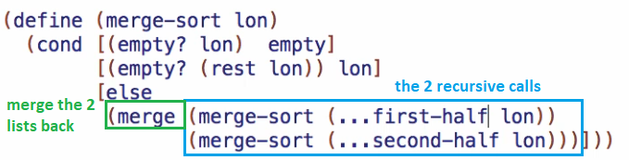

Getting the first-half:

* Wish for a **take** function that will take the front half of the list



Getting the 2nd half:

* Wish for a **drop** function
  + Drop the same things on the front of the list and return the back half

